Terms of Reference Agreement: The Friends of St. Mary’s Church, Stevington & Stevington PCC re use and management of The Church Room/Stevington Community Hub
Updated Draft v3 Discussed Fosms trustees 27/04/2026 PCC to discuss 2026 following retirement of Tricia Lennie from PCC
Ownership
The building was constructed in 1898 on land donated by Herbrand, Eleventh Duke of Bedford. He also donated £100 towards the costs of a ‘Mission Room’ some 400m from the Church building. It should be noted that the remainder of the money for construction and fitting out was raised by Stevington residents.
The trust deed is between the Duke of Bedford and the Ely Diocesan Trustees, who were the administrative centre of village life in this area in the 1890s.
In 1914, the new Diocese of Chelmsford was formed, removing Essex from the St Albans diocese. A few months later the county Archdeaconry of Bedford was added to St. Albans from the Diocese of Ely, thereby providing the diocese substantially with its current boundaries.
In 1956 Stevington Parochial Church Council were appointed as Administrative Trustees and are Beneficial Owners of the building. The Estates Officer in St Albans has retained the Trust Deed on the PCC’s behalf.
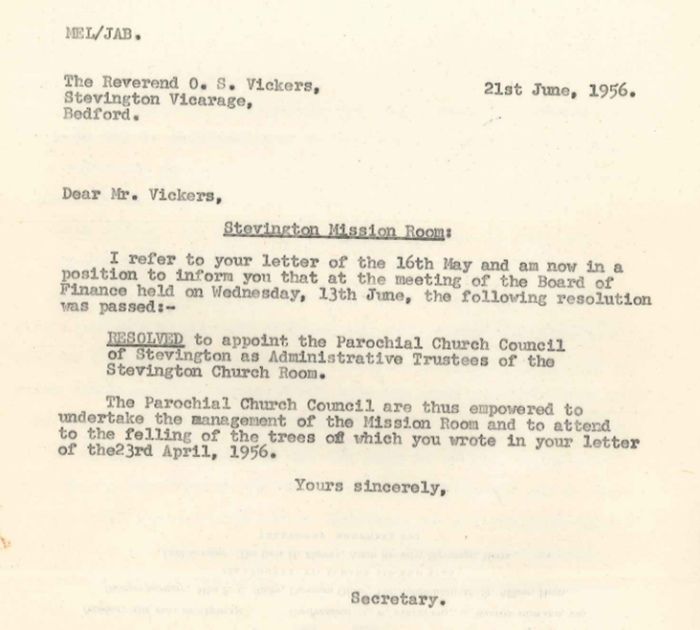
In 2010 The Friends of St. Mary’s Church, Stevington (Registered Charity No 1139161) was established, and trustees have developed the room as Stevington Community Hub, a publicly accessible resource providing for the modern day ‘spiritual, moral, social or intellectual wants’ of residents and visitors. The Friends’ Annual Review documents show the range of activities, services and opportunities provided by the trustees and volunteers. Despite the construction of the Link Building (officially opened March 2025) which has provided extra storage space, indoor toilets and a functional gallery space, this Victorian building remains in need of considerable upgrade to its facilities.

Roles
The PCC and The Friends of St. Mary’s Church have defined roles in the development of the building historically known as The Church Room. Many of the activities will be run under the name of Stevington Community Hub.
As Beneficial Owners the PCC are responsible for:
- Applying for planning permission to develop the building [Nov 2020, Jan 2026, June 2026]
- Awarding contracts for capital, renovation and maintenance work and paying resultant invoices
- Managing and overseeing all building work and liaising with users
- Paying utility and running costs: insurance, electricity, water,
- Ensuring that the building has appropriate building, contents, public and trustee liability cover for PCC
- Ensuring that the building meets current Health and Safety regulations, including during building work.
- Overseeing use, bookings and invoicing [ this can be delegated]
- Agreeing rents and managing user contracts
- Raising invoices for users
- Receiving private hire income
- Overseeing security and key holders
- Applying for grants
- Giving permission for any material changes to the building [e.g. installation of a water boiler in the kitchen area]
- NB Suggestion that formal arrangements are made for a PCC Hall Manager
As the supporting fundraising body, FOSMS are responsible for:
- Running fundraising events
- Supporting the development and running costs of the Hub
- Ensuring that the FOSMS organisation is covered by public liability and trustee liability
- Ensuring that FOSMS events are run with current H&S regulations in mind
- Developing user groups and events, and supporting a stakeholders committee
- Liaising with and supporting the Community Shop (FOSMS ineffective here)
- Overseeing the design development (is that what PCC want?)
- Stimulating private hire
- Managing the interactive TVs
- Paying for WiFi
- Applying for grants for activities and capital projects
- Monitoring use to ensure impact and outcomes
- Ensuring that equipment purchased is included on an Assets List and insured by PCC.

Aims and Vision 2023-2028 (NB Whose aims and vision are these? PCC, FOSMS or joint?)
Aim:
- To create a financially sustainable, multi-user community project known as Stevington Community Hub which supports the modern day ‘spiritual, moral, social or intellectual wants’ of residents and visitors.
- To create an agreed, detailed 5-year plan for the running and development of the Church Room and Community Hub project.
Vision:
- The Hub will be a welcoming, community space; support a community shop, drop-in WiFi enabled café and a range of clubs and activities to meet the needs of the whole local demographic.
- Any surplus funds raised will be used in accordance with FOSMS charitable objectives.
- The Hub building will be available to book for private hire
- The Hub building will be gradually renovated to improve access, energy efficiency, facilities and décor.
While the aims and vision are realised over the 2023-2028, 5-year period, the following has been agreed as a modus operandi between Stevington PCC and The Friends of St. Mary’s Church Stevington AS AT 2023 2026
Legal responsibility
- Insurance buildings and contents of The Church Room/Community Hub: Currently with AVIVA via Trinitas Church Insurance. Policy Number 155172369. Qs raised re shop contents and theft cover. Paid for by PCC.
- Health and Safety: Report on The Church Room/Community Hub completed by Pete Fisher for PCC 10th January 2023.
Several issues were raised to meet current legislation. The PCC would like FOSMS to manage the monthly testing records and risk assessments. Dr J Strutt is the current FOSMS trustee H&S co-ordinator. He has agreed to list problems and potential solutions.
N.B. This arrangement does not absolve the PCC from their responsibility as the legal owner of the building, but in practice, FOSMS have more capacity to ensure that policy is agreed, and regular checks are undertaken. Safeguarding and Health & Safety appear on every FOSMS Agenda.
Any costs arising are the responsibility of PCC but assistance may be requested from FOSMS.
Monthly checks of fire alarms are being recorded by FMH.
Fire evacuation practice has been undertaken JS/FMH.
Process needs streamlining to respond to H&S concerns e.g. steps and light, porch stability, roof integrity.
- Bookings: The bookings diary is in transition between Tricia Lennie and Robert Eadie Q2/Q3 2026. Tricia is no longer a member of PCC. Invoices to be raised and hire charges to be paid to PCC
- Maintenance: Occasional maintenance issues will arise. Who should manage these? Who will manage volunteers or contractors? Who will pay invoices?
Bookings and Maintenance responsibility needs to be resolved
NB There is a memorandum of understanding between PCC and FOSMS that when funds are requested from FOSMS to PCC or vice versa, a letter will be written from the secretary to the secretary for consideration at the next available meeting of trustees. This request should be sent before costs are incurred. Chairs and Treasurers should be copied in.

Finance
- Income: FOSMS Trust Deed states that it exists to fundraise for the maintenance and improvement of the Church and Church buildings. It can accept donations, grant payments and organises fundraising events. It cannot be involved in permanent trading.
As a Registered Charity 1139161, it must make a return to the Charity Commission annually and produce an Annual Report for members. The treasurer will ensure that grant money is spent according to allocated budget headings and that a sensible reserve policy is set for payment of regular bills (such as the broadband and insurance).
FOSMS has asked Heather Parkinson to be the independent scrutineer for 2025 accounts

Expenditure: Monies received in the FOSMS bank account are used at the discretion of FOSMS trustees and decisions are made in accordance with current policy.

As noted above, requests can be made by PCC to FOSMS for support with proposed expenditure.
FOSMS agreed to contribute £800 per annum to PCC funds to mitigate loss of interest payments at 2.6% on the £30,000 they have contributed to the construction of the link building. See FOSMS Minutes of 9th March 2023. Payments commenced when the money was withdrawn from the PCC savings account in 2024.

- Assets list: Some items currently installed in the Hub have been paid for directly from grants or donations made to FOSMS, such as the TV, Toddler area, ladders and some kitchen equipment. FOSMS will start an asset list, but items will be insured under the PCC contents insurance.
- Invoices paid:
Running costs - When trustees have agreed that money is to be transferred from FOSMS bank account to PCC bank account, for example for cleaning services or rent support, invoices will be raised by the PCC, sent to the FOSMS treasurer who will make payment and retain these for audit purposes.
Process needs streamlining
Capital build – The PCC are responsible for contracts and payments relating to capital expenditure. However, some grant monies received by FOSMS are designated for capital build.
FOSMS will transfer any grant monies, once received by FOSMS, for capital building expenses as needed for current invoices.

- Grants: Care must be taken as both organisations may, from time to time, apply for grants related to either capital, renovation, or project work. PCC/FOSMS must liaise closely to align Aims and Vision, maintain positive working relationships with grant funders, avoid any duplication of effort or request for funds. Grant applications for both organisations (whether in relation to the building or the project) must be agreed initially between PCC Treasurer and a FOSMS trustee (the Chair unless otherwise specified). Each organisation will have its own policy for decision making.

Development of Stevington Community Hub – to be jointly discussed

Events, responsibility for and associated funding: Current events include Community Shop (which is a separate organisation paying rent to PCC); a drop-in WiFi enabled café (staffed mostly by shop volunteers but supplemented by FOSMS/PCC, profits accrue to the shop); interest groups run in conjunction with shop opening such as Stevington Singers (FOSMS); coffee mornings (FOSMS); an Arts and Crafts group (FOSMS); a gallery in the link building (FOSMS) Toddler area (FOSMS); wellbeing talks (FOSMS); second-hand books (FOSMS) Wavelength (independent); soup lunches (PCC) Private hires including an exercise group and WI (PCC)

Renovation work – Future projects will be considered within the 5-year plan, such as the safety and integrity of the building, accessibility, energy efficiency, fabric, utilities, and decor improvements. These will need to be prioritised, and resources allocated to their management and fulfilment.
- Current project is replacement windows 2026, Grant secured. Planning approval outstanding. Project manager is ???
- The roof and porch are failing and present urgent safety concerns
- Community energy initiative
- Disabled access
- Hub management group: Is there one? Who runs this?
- The first meeting of the stakeholders’ group in March 2022 was called and run jointly by PCC and FOSMS
- This group discussed achieving the Aims of the Hub, which are to be financially sustainable and to be a vibrant multi-user community resource. Do we want an updated meeting in 2026?
- The PCC hoped that management and running of Hub events could increasingly be transferred to FOSMS or a Hub management group. What do FOSMS want in 2026?
- While FOSMS are eager to see the Community Hub project flourish, they are restricted by the current Trust Deeds from undertaking any permanent trading and restricted from full legal responsibility for aspects of building management.
- A committee could be formed, comprising key personnel in a structure that simplifies these challenges.
- Is a Hall Manager with a defined role needed or do PCC expect Robert Eadie to assume this role as Booking Manager
- The evolution of a management group could form part of the 5-year-plan
- FOSMS evolution to CIO is independent of the above
Communication
All parties will be considerate in their communications. Everyone is busy, so, we must be thoughtful in our expectations of each other’s time. Most correspondence will be by email. If we urgently need to talk, then we should text to agree a suitable time for the discussion and respect one another may not be instantly available. Discussions will happen in normal working hours or times agreed by participants.
ENDS

